**Chapter 1**

**INTRODUCTION**

**Abstract:**

**1.1 About the Project:**

Pancreatic cancer begins in the tissues of your pancreas — an organ in your abdomen that lies horizontally behind the lower part of your stomach. Your pancreas releases enzymes that aid digestion and hormones that help manage your blood sugar.

Pancreatic cancer typically spreads rapidly to nearby organs. It is seldom detected in its early stages. But for people with pancreatic cysts or a family history of pancreatic cancer, some screening steps might help detect a problem early. One sign of pancreatic cancer is diabetes, especially when it occurs with weight loss, jaundice or pain in the upper abdomen that spreads to the back. Treatment may include surgery, chemotherapy, radiation therapy or a combination of these.

Pancreatic cancer occurs when cells in your pancreas develop mutations in their DNA. These mutations cause cells to grow uncontrollably and to continue living after normal cells would die. These accumulating cells can form a tumour. Untreated pancreatic cancer spreads to nearby organs and blood vessels.

Most pancreatic cancer begins in the cells that line the ducts of the pancreas. This type of cancer is called pancreatic carcinoma or pancreatic exocrine cancer. Rarely, cancer can form in the hormone-producing cells or the endocrine cells of the pancreas. These types of cancer are called islet cell tumours, pancreatic endocrine cancer and pancreatic endocrine tumours.

**Some of the very useful metrics would be:**

* Chronic inflammation of the pancreas (pancreatitis)
* Diabetes
* Family history of genetic syndromes that can increase cancer risk, including a BRCA2 gene mutation, Lynch syndrome and familial atypical mole-malignant melanoma (FAMMM) syndrome
* Family history of pancreatic cancer

**Chapter 2**

**SYSTEM ANALYSIS**

**2.1 Existing System:**

In this system, pancreatic cancer happens when uncontrolled cell growth begins in a part of the pancreas. Tumours develop, and these interfere with the way the pancreas works.

**2.2 Proposed System:**

In this system, accurate pre treatment staging of pancreatic cancer is a crucial initial step in the development of a stage-specific treatment plan, either on- or off-protocol for any patient with pancreatic cancer. Importantly, current American Joint Committee on Cancer staging utilizes the maximal information available; if surgery has been performed, then pathological information from the respected specimen will provide additional information for both T and N staging. If surgery has not been performed, then staging is based on information from available cross-sectional imaging studies.

Although American Joint Committee on Cancer staging was modified in the sixth edition to reflect the survival difference between patients with operable/respectable versus non operable/unrespectable disease, the precise definitions of respectability continue to evolve. It is essential for clinicians of different specialties to understand the definitions of respectability to facilitate optimal patient care and to allow for accurate interpretation of the literature. This review focuses on important aspects of the pre treatment assessment of patients with particular attention to definitions of respectability.

**MODULES**

1. Tumour size
2. Radius
3. Diagnosis
4. Area
5. Perimeter
6. Concavity
7. Compactness
8. Smoothness
9. Symmetry

**2.3 OBJECTIVES:**

To develop a world-class clinically annotated bio-sample repository from patients with **pancreatic** diseases and **cancer**. Thus, this research tissue bank will be critical to develop and validate **pancreatic cancer** biomarkers. ... Thus, the overall **objective** remains to prolong life of **pancreatic cancer** patients.

**VISION:**

The predictive performance of machine learning is compared with that of the linear and logistic regression techniques that dominate the medical oncology literature.

**MISSION :**

* To create a premier Pancreatic Cancer Center where all needs of pancreatic cancer patients can be met in one location with the most advanced treatment options.
* To be recognized as a patient support reference source for pancreatic cancer patients and their families.
* To fund projects and programs designed to improve patient care, treatment and, ultimately, pancreatic cancer survival rates.

**2.4 Feasibility Study**

This is a Feasibility study to determine the safety and efficacy of a new branch therapy device that provides unidirectional radiation which utilizes active components (Palladium-103) of standard devices in a novel configuration .This pilot study may benefit pancreatic cancer patients by reducing the radiation dose to adjacent critical structures, while giving a therapeutic dose to diseased tissue, such as at a surgical margin. The appropriate dose and local control rate will be recorded the primary endpoint in order to provide an efficacy assessment.

**CHAPTER 3**

**SYSTEM DESIGN**

**3.1 Architecture:**

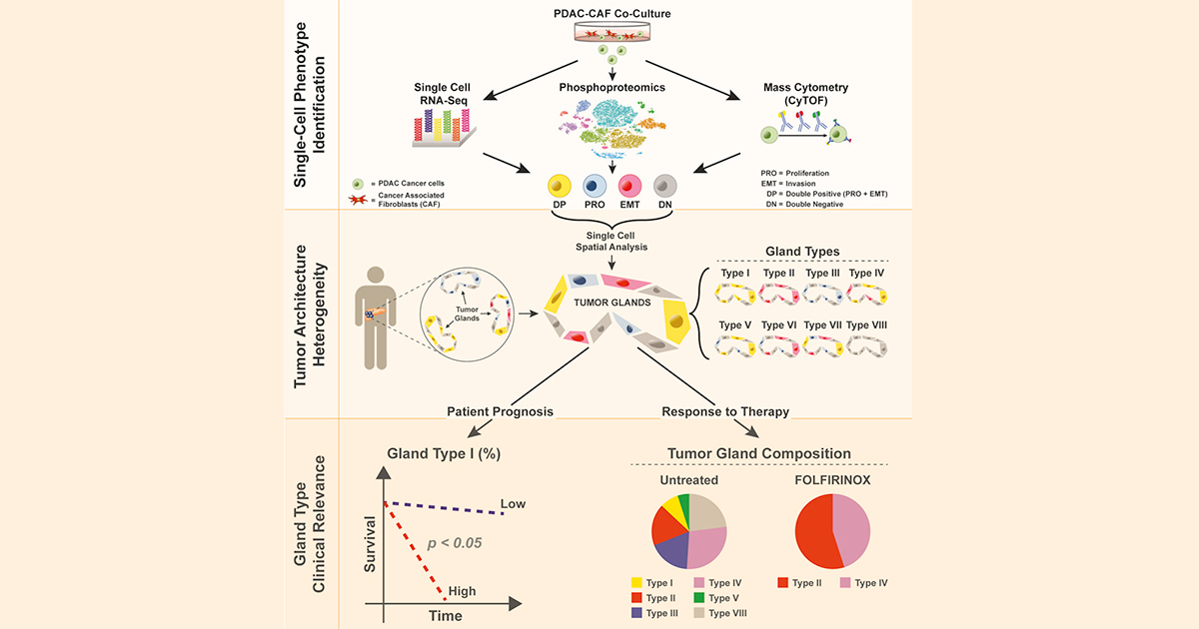

**3.2 Sample of Market Research Analysis:**

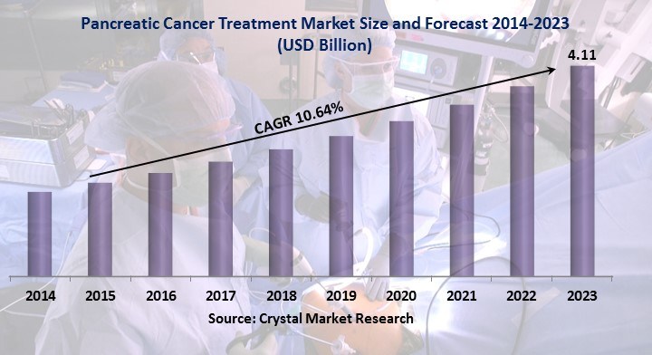

**Chapter 4**

**System Environment**

**PYTHON:**

Python is a general-purpose interpreted, interactive, object-oriented, and high-level programming language. An interpreted language, Python has a design philosophy that emphasizes code readability (notably using whitespace indentation to delimit code blocks rather than curly brackets or keywords), and a syntax that allows programmers to express concepts in fewer lines of code than might be used in languages such as C++ or Java. It provides constructs that enable clear programming on both small and large scales. Python interpreters are available for many operating systems. C, Python, the reference implementation of Python, is open source software and has a community-based development model, as do nearly all of its variant implementations.

**Anaconda**

Python is a widely used high-level, general-purpose, interpreted, dynamic programming language. Its design philosophy emphasizes code readability, and its syntax allows programmers to express concepts in fewer lines of code than would be possible in languages such as C++ or Java. Thelanguage provides constructs intended to enable clear programs on both a small and large scale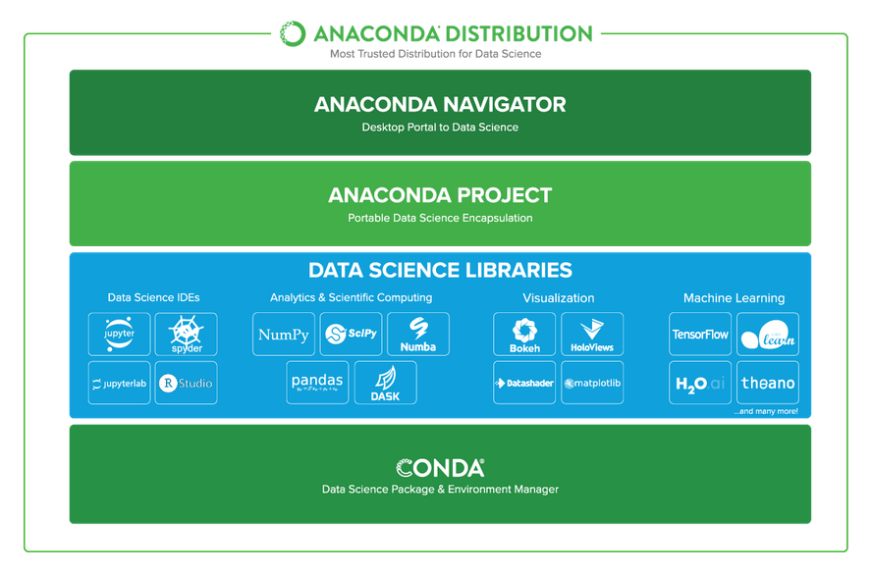

**Chapter 5**

**Modules**

**List of Modules:**

1. Diagnosis
2. Tumour size
3. Radius
4. Area
5. Perimeter
6. Concavity
7. Compactness
8. Smoothness
9. Symmetry
10. **Diagnosis:**

**Imaging tests that create pictures of your internal organs .Using a scope to create ultrasound pictures of your pancreas. Removing a tissue sample for testing (biopsy).**

1. **Tumour Size:**

Malignant tumours are cancerous tumours that can potentially result in death. Unlike benign tumours, malignant ones grow quickly, and can spread to new territory in a process known as metastasis. The abnormal cells that form a malignant tumour multiply at a faster rate.

**3. Radius:**

However, even though they are not cancerous, some may press against nerves or blood vessels and cause pain or other negative effects. Benign tumours of endocrine tissues may result in the excessive production of some hormones.

1. **Area:**

These lesions are microscopic abnormalities in the pancreas and are often found in [autopsies](https://en.wikipedia.org/wiki/Autopsy) of people with no diagnosed cancer. These lesions may progress from [low to high grade](https://en.wikipedia.org/wiki/Cancer_grading) and then to a tumour, More than 90% of cases at all grades carry a faulty [*KRAS*](https://en.wikipedia.org/wiki/KRAS) gene.

**5. Perimeter:**

The cancer is confined to the top layers of pancreatic duct cells and has not invaded deeper tissues.

It has not spread outside of the pancreas. These tumours are sometimes referred to as carcinoma

**6. Concavity:**

Location of **pancreatic tumours**: 70-75% in the head of the **pancreas**, 15-20% in the body, and 5-10% in the tail. **Average size** of **tumours** at diagnosis: 2.5-3.5 cm in the **pancreatic** head and 5-7cm in the body and tail.

**7. Compactness:**

# Tumor Compactness Improves the Pretreatment Volumetry - Based Prediction for Pathological Complete Response of Rectal Cancer After Neo adjuvant Concurrent Chemo radiation Therapy.

# 8. Smoothness:

A tumour is an abnormal growth of cells that serves no purpose. A benign tumour is not a malignant tumour, which is [cancer](https://www.webmd.com/cancer/default.htm). It does not invade nearby tissue or spread to other parts of the body the way [cancer](https://www.webmd.com/cancer/ss/does-this-cause-cancer) can. In most cases, the outlook with [begin tumours](https://www.webmd.com/a-to-z-guides/benign-tumors-causes-treatments) is very good.

**9.Symmetry:**

Discount is a factor through which we can attract the customers to visit café. Discount plays a major role to gain the profits.

.

**Chapter 6**

**Algorithm**

**Logistic Regression**

Logistic regression is a [statistical model](https://en.wikipedia.org/wiki/Statistical_model) that in its basic form uses a [logistic function](https://en.wikipedia.org/wiki/Logistic_function) to model a [binary](https://en.wikipedia.org/wiki/Binary_variable) [dependent variable](https://en.wikipedia.org/wiki/Dependent_variable), although many more complex [extensions](https://en.wikipedia.org/wiki/Logistic_regression#Extensions) exist. In [regression analysis](https://en.wikipedia.org/wiki/Regression_analysis), **logistic regression** (or **logistical regression**) is [estimating](https://en.wikipedia.org/wiki/Estimation_theory) the parameters of a logistic model (a form of [binary regression](https://en.wikipedia.org/wiki/Binary_regression)). Mathematically, a binary logistic model has a dependent variable with two possible values, such as pass/fail which is represented by an [indicator variable](https://en.wikipedia.org/wiki/Indicator_variable), where the two values are label "0" and "1". In the logistic model, the [log-odds](https://en.wikipedia.org/wiki/Log-odds) (the [logarithm](https://en.wikipedia.org/wiki/Logarithm) of the [odds](https://en.wikipedia.org/wiki/Odds)) for the value label "1" is a [linear combination](https://en.wikipedia.org/wiki/Linear_function_(calculus)) of one or more [independent variables](https://en.wikipedia.org/wiki/Independent_variable) ("predictors"); the independent variables can each be a binary variable (two classes, coded by an indicator variable) or a [continuous variable](https://en.wikipedia.org/wiki/Continuous_variable) (any real value). The corresponding [probability](https://en.wikipedia.org/wiki/Probability) of the value label "1" can vary between 0 (certainly the value "0") and 1 (certainly the value "1"), hence the label; the function that converts log-odds to probability is the logistic function.

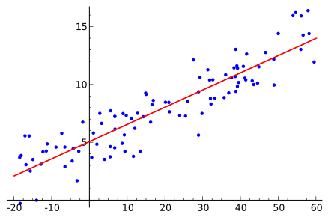

**Chapter 7**

**Implementation**

**Sample code to display dataset**

import numpy as np

import pandas as pd

df=pd.read_csv("cancer1.csv")

df

**Sample code to display Quantity graph**

import numpy as np

import pandas as pd

import seaborn as sns

import matplotlib.pyplot as plt

%matplotlib inline

df=pd.read_csv('cancer1.csv')

sns.set_style('whitegrid')

df['Diagnosis'].hist(bins=30)

plt.xlabel('Diagnosis')  
  
**Sample code to display jointplot for area and rate**

sns.jointplot(x='radius_mean',y='texture_mean',data=df)

**Sample code to display jointplot for quantity and rate**

sns.jointplot(x='perimeter_mean',y='area-mean',data=df,color='green')

**Sample code to display independent variables**

from sklearn.cross_validation import train_test_split

import numpy as np

import pandas as pd

df=pd.read_csv('cancer1.csv')

## x=df.iloc[:,[0,2,3,4,5,6,7,8,9,10,11,12,13,14,15,16,17,18,19,20,21,22,23,24,25,26,27,28,29,30]].values x

**Sample code to display dependent variables**

y = df.iloc[:,(1)].values

y

**Sample code for Logistic Regression**

x_train,x_test,y_train,y_test=train_test_split(x,y,test_size=0.33,random_state=42)

from sklearn.linear_model import LogisticRegression

logmodel=LogisticRegression()

logmodel.fit(x_train , y_train)

**Sample code for Decision tree Classifier**

from sklearn.tree import DecisionTreeClassifier

dtree=DecisionTreeClassifier()

dtree.fit(x_train,y_train)

**Sample code for predictions**

predictions=dtree.predict(x_test)

from sklearn.metrics import classification_report,confusion_matrix

print(classification_report(y_test,predictions))

print(confusion_matrix(y_test,predictions))

**Sample code to calculate bit of error**

from sklearn import metrics

print('MAE:',metrics.mean_absolute_error(y_test,predictions))

print('MSE: ',metrics.mean_squared_error(y_test,predictions))

print('RMSE:',np.sqrt(metrics.mean_squared_error(y_test,predictions)))

**Chapter 8**

**OUTPUT SCREENS**

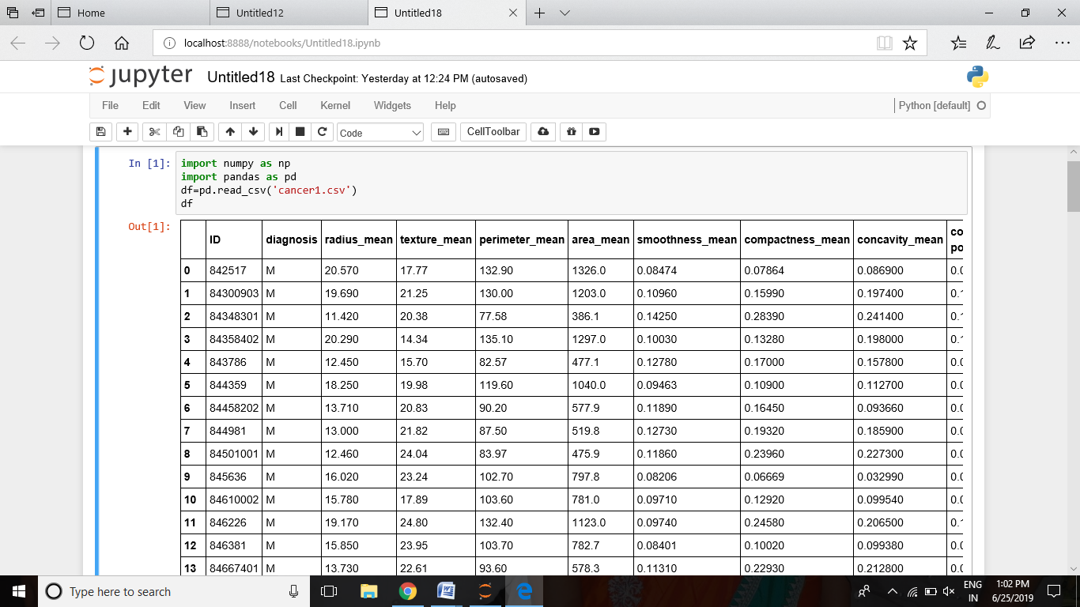

The above result shows the 20,000 patients dataset

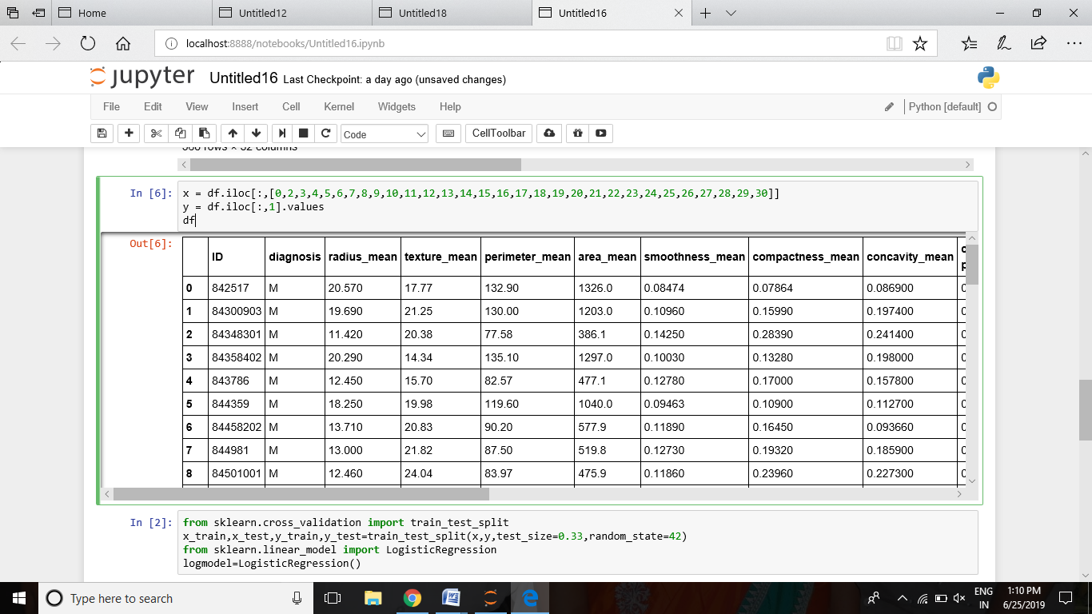

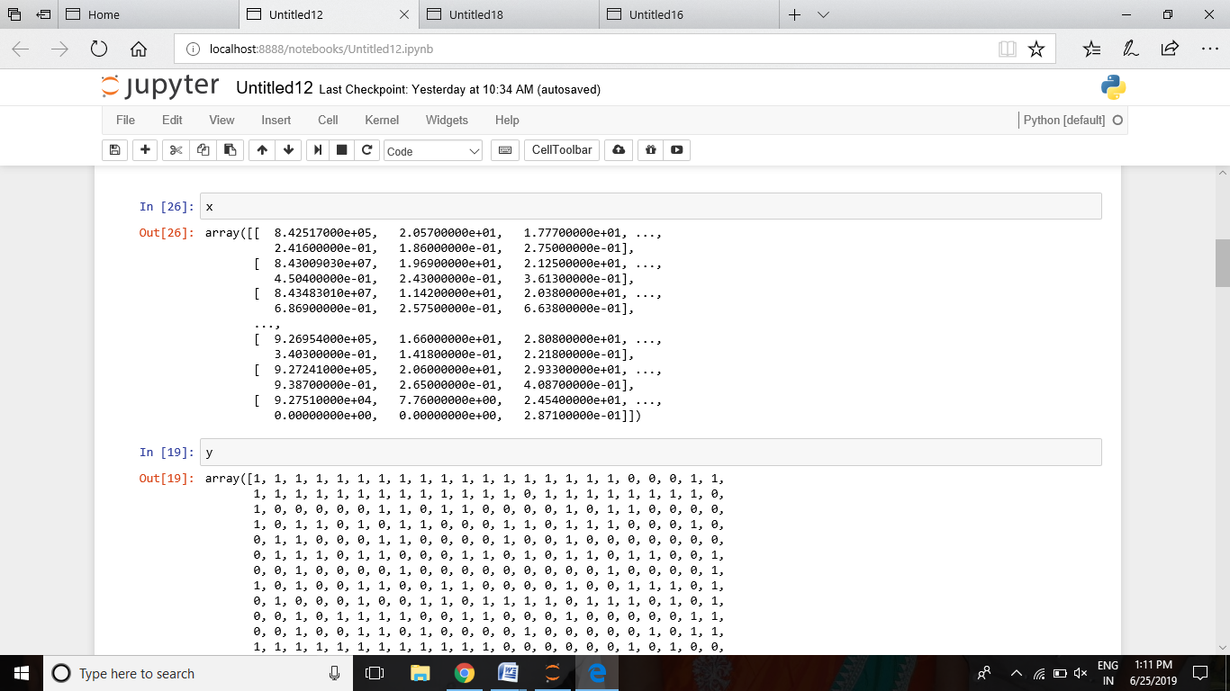

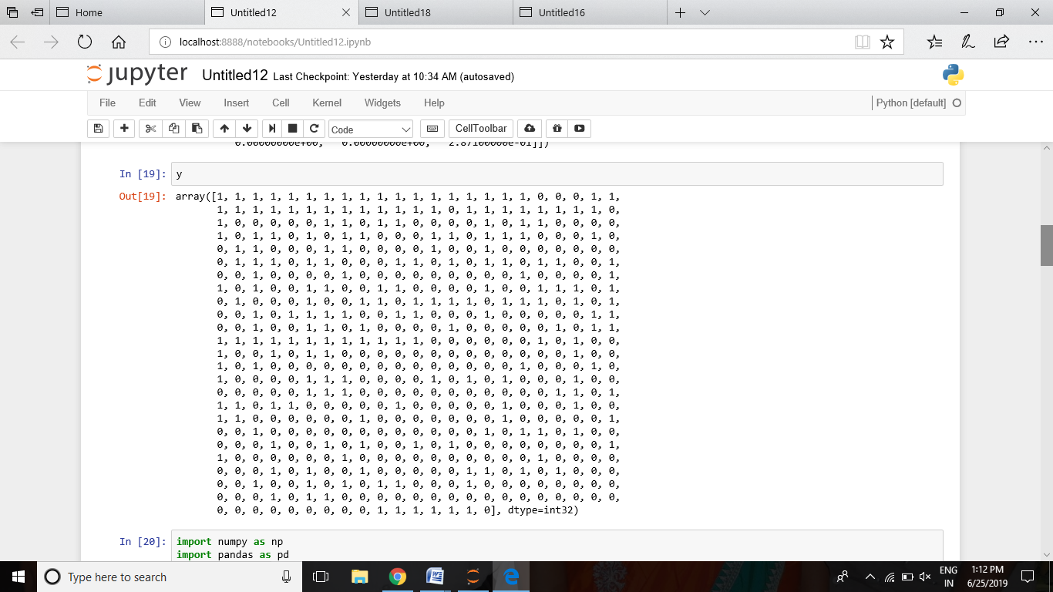

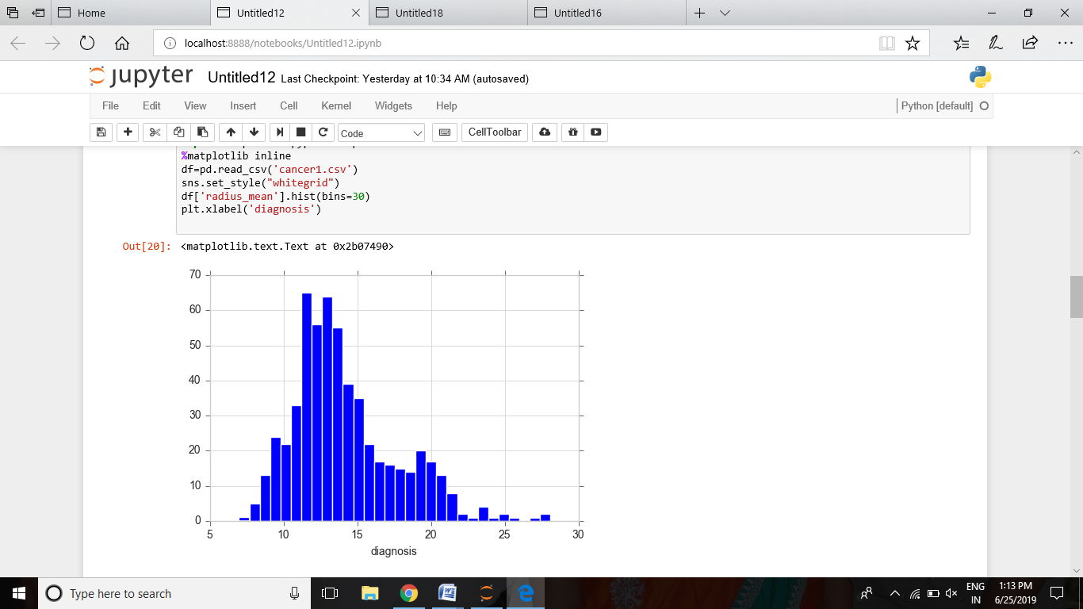

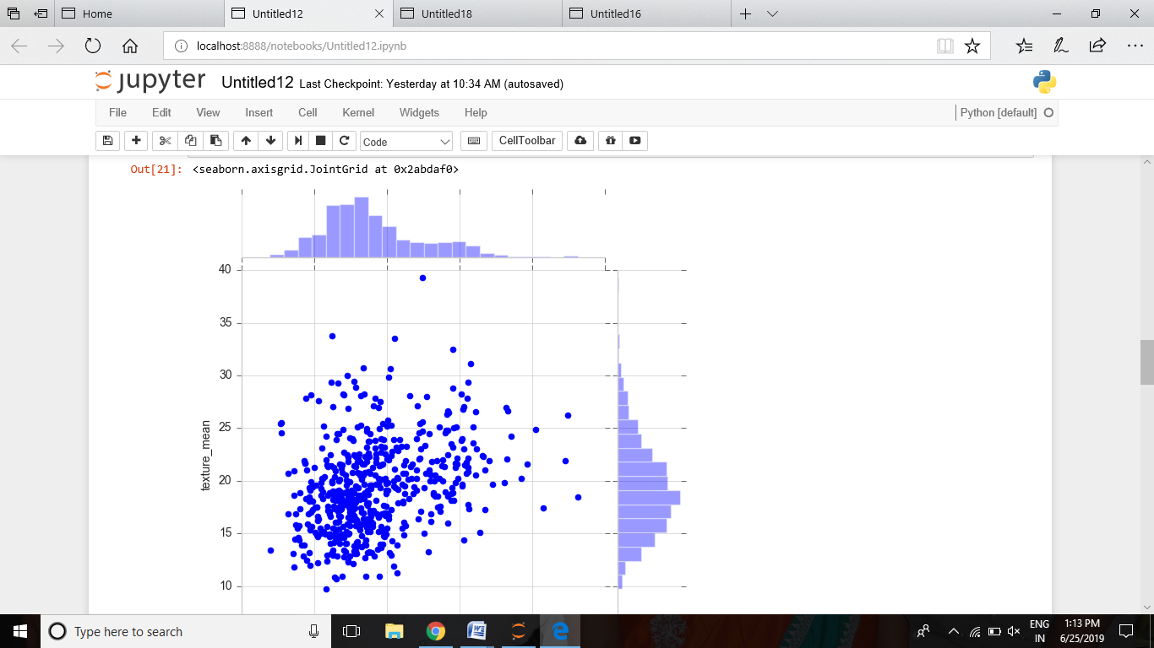

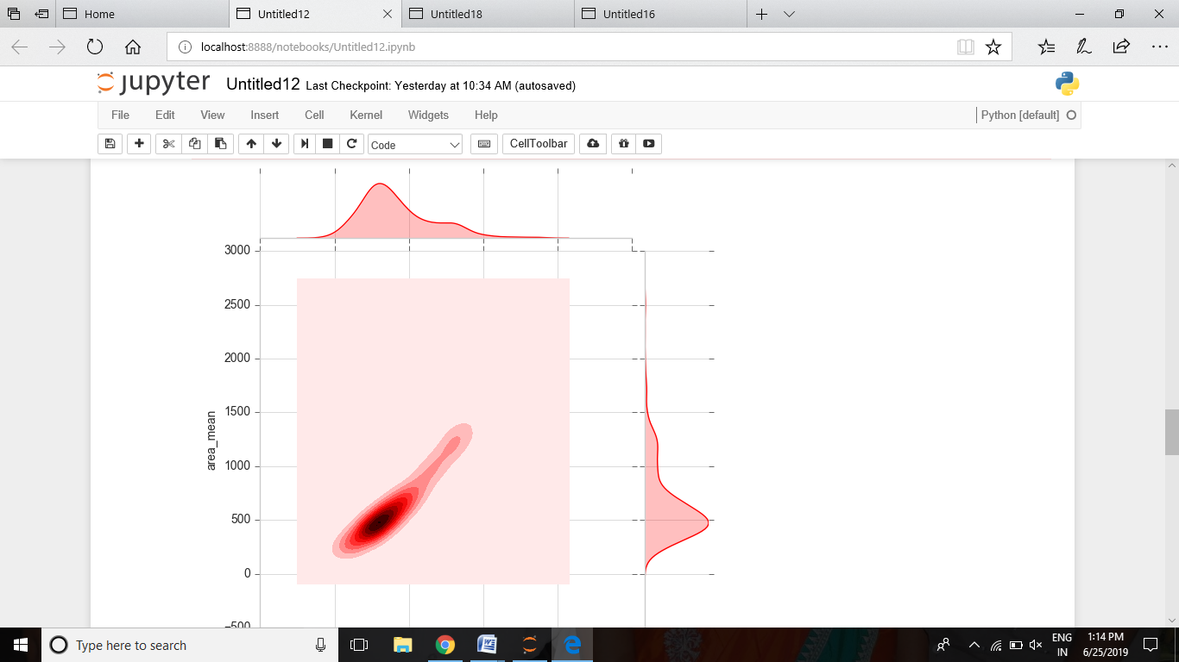

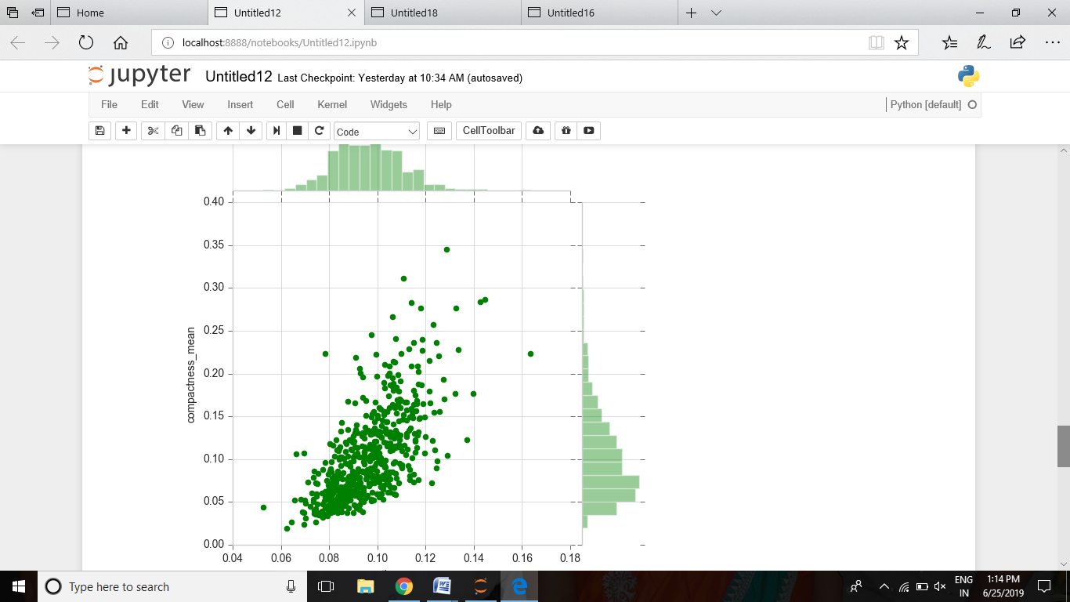

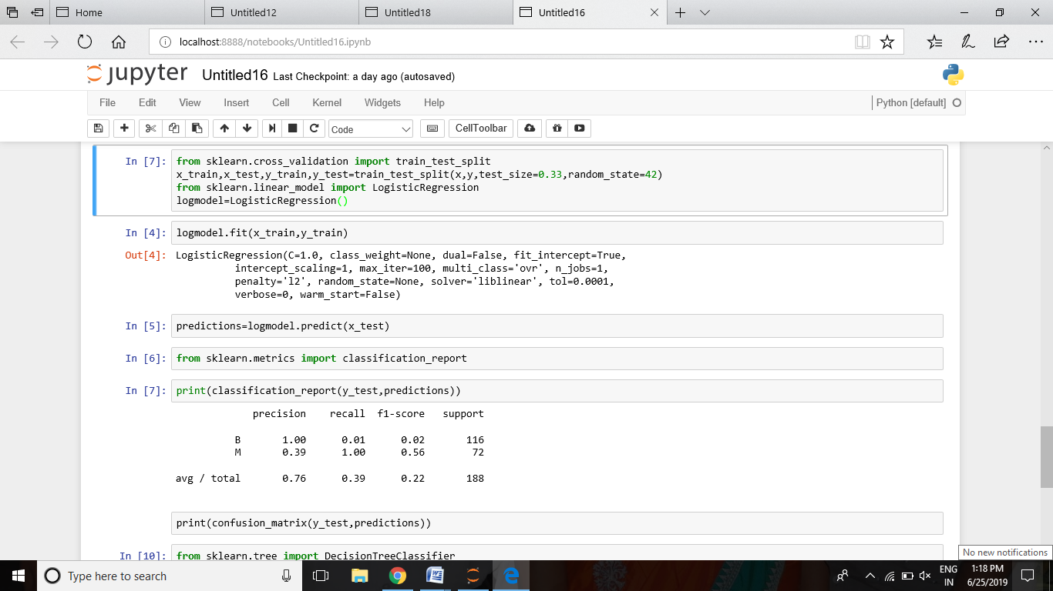

The above result shows about logistic regression and decision tree classifier

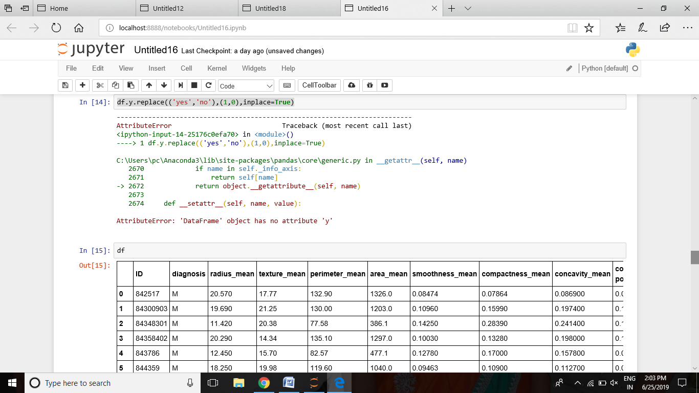

The above result shows about databits either ‘0’ or ‘1’.

**CHAPTER 9**

**REQUIREMENT ANALYSIS**

**9.1 Software Requirements:**

Operating System : windows 7 Ultimate

Coding Language : Python

Editor : Jupyter Notebook

Server : Anaconda Server(Dashboard)

Command Prompt : Anaconda Prompt

**9.2 Hardware Requirements:**

Preprocessor : i3 (minimum),i5

RAM : 4GB (minimum)

Mouse : Optical Mouse

Monitor : 15.6’ colour Monitor

Hard disk : 1TB

**Chapter 10**

**Advantages and Disadvantages**

**Advantages:**

* The main advantage of surgery is that it is the most effective treatment for removing pancreatic cancer and can help you to live longer.
* Some of your symptoms such as jaundice, pain and problems with digestion may improve after surgery.
* If the cancer does come back, you may be able to have further treatment with chemotherapy to control the cancer and your symptoms.

**Disadvantages**

* Pancreatic surgery is major surgery and as with any major operation there are some [risks](https://www.pancreaticcancer.org.uk/information-and-support/treatments-for-pancreatic-cancer/surgery-to-remove-pancreatic-cancer/advantages-and-disadvantages/#risks).
* You will need to stay in hospital afterwards to recover. This may be between a week and two weeks
* Depending on the type of surgery, it can take three to nine months to recover. For some people it could take up to a year to fully recover.
* Such as problems digesting your food and diabetes. But the cancer may cause these symptoms even if you don’t have surgery

**Chapter 11**

**Conclusion**

There is a big opportunity waiting to be utilized by the more entrepreneurial and innovative restaurant owners. Whoever takes the lead will win. Soon, there will be no other option but to innovate and devise strategies, keeping the customer at the heart of all your decision making. The rate at which this space is growing, it will be difficult for laggards to survive. Analytics provides the only solution to ensure scalability, efficiency, keys to customer satisfaction and above all, increased revenues. With the growing demands for more immersive quality of experience from consumers, quality monitoring in multimedia content delivery especially via broadcast services assumes a significant role in today’s scenario. To that end, ML based quality predictors offer a plausible solution. Moreover, promising results from related disciplines such as computer vision and the availability of required hardware (e.g., GPU-accelerated computing) have opened up possibilities of developing efficient ML based implementations of quality predictors. However, proper validation and benchmarking of such ML based quality estimators is important prior to deployment. In that context, the main goal of the paper was to highlight few drawbacks associated with the current approach of statistical comparison and validation. These stem primarily from lack of considerations to theoretical and practical aspects of statistical testing.

**Chapter 12**

**Future Scope:**

Future work should consider further advantages of data mining, particularly the expressiveness of the resulting models and their potential usefulness to clinicians in understanding the factors that influence disease state and in making clinical decisions. One technical gap to consider in future work is the trade-off between smaller feature-rich data set, and other available data sets which provide larger numbers of patients but comparatively less individual detail.

**Chapter 13**

**References**

[1]--Medline Plus. Glucagonoma [online] Available from:

<http://www.nlm.nih.gov/medlineplus/ency/article/000326.htm> .

 [2]--Medline Plus. Insulinoma [online] Available from:

<http://www.nlm.nih.gov/medlineplus/ency/article/000387.htm>.

 [3]--Medline Plus. VIPoma. [online] Available from:

<http://www.nlm.nih.gov/medlineplus/ency/article/000228.htm>.

 [4]--Medline Plus. Zollinger-Ellison syndrome [online] Available from:

<http://www.nlm.nih.gov/medlineplus/ency/article/000325.htm>

 [5]--National Cancer Institute. What you need to know about cancer of the pancreas. [online]

Available from:

<http://www.cancer.gov/cancertopics/wyntk/pancreas/page2>.

[6]--NET Patient Foundation. Information, advice and support for people living with or caring .

Available from:

<http://dev.dustedesign.com/_sites/npf/wpcontent/uploads/NPF_Booklet_gastrinomas_V2.Pdf>

[7]--NET Patient Foundation. Information, advice and support for people living with or caring for those with Insulinomas.

Available from:

<http://dev.dustedesign.com/_sites/npf/wpcontent/uploads/NPF_Booklet_insulinomas_V2.pdf>

[8]--NET Patient Foundation. Information, advice and support for people living with or caring for those with

Non-functioning Pancreatic Neuro endocrine Tumours (PNETS)

Available from:

<http://dev.dustedesign.com/_sites/npf/wp>.